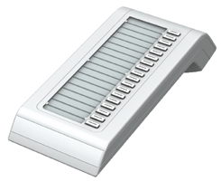
OpenStage Key Module 15
#

